
Sister Clare Marie Trettel
Distinguished Scholar Award Application

Name: Click here to enter text.
Address: Click here to enter text.
City: Click here to enter text.
State: Click here to enter text. Zip Code: Click here
Telephone: Click here to enter text.
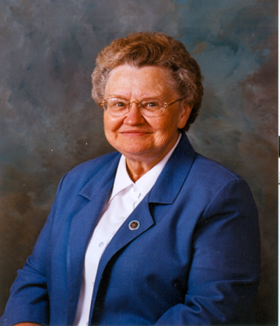

Directions: Document completion of six significant activities in the following three categories (at least one in each). All experiences need previous approval by one of the SOE faculty contacts.

Professional Growth: Work as research assistant to faculty, publication of article or book, participation in state or national education or content area convention, other*.

Click here to enter text.

Service: Significant volunteer work in schools, Service Learning Experience, HECUA experience, Study Abroad, Dignitas Mentoring or peer tutoring, Special Assignment; work for School of Education faculty member, other*.

Click here to enter text.

Sister Clare Marie Trettel
Distinguished Scholar Award Application

Leadership: Curricular/grade level area chair in a school setting, officer in School of Education student organization, organizer/leader of three major activities in School of Education Student Organization, leader of a student organization, captain of athletics team, Student Senate member, other*.

Click here to enter text.

*Must be developed with an SOE faculty contact.

Undergraduate Faculty Contacts

John Bauman – jbauman@css.edu
Randy Bowen – rbowen@css.edu

Graduate Faculty Contacts:

Duluth
Gail Gaetz – ggaetz@css.edu
Randy Bowen – rbowen@css.edu

St. Cloud
Jesse Hinrichs – jhinrich@css.edu

St. Paul
Doreene Langason – dlangaso@css.edu

School of Education general information:
Cindy Mattson – (218) 723-6108

